|  |  |  |
| --- | --- | --- |
| **Document No:** | **Document Name:**  Okuma 3 UMC 3”, 4”, 6” Machining Process | **Pages: 7** |
| **Revision No:** | **Revision Date:** | **Area Supervisor:**  Brenda Goodman |
| **Issued Date:** | **Prepared by:** J. Switala, M. Hajian | **Approved by:** |

1. **Purpose:** To provide instructions for machining UMC valves.
2. **Scope:** To standardize the machining process of the 3”, 4”, and 6” UMC valves to meet design requirements.
3. **Responsibility:** To be performed by trained operator, department leader, or supervisor.
4. **Terminology/Defined terms:**
   * Table: rotatable metal table where the subplate attaches. Commonly referred to as a pallet or block.
   * MDI: Manual Data Input
5. **Tools:** Use all required tools: 1 1/4” wrench, pneumatic hand grinder, file, square, 5/16” and 3/8” hex keys.
6. **Safety:** Follow all Globe Fire Sprinkler machine safety requirements.
7. **Procedure:**

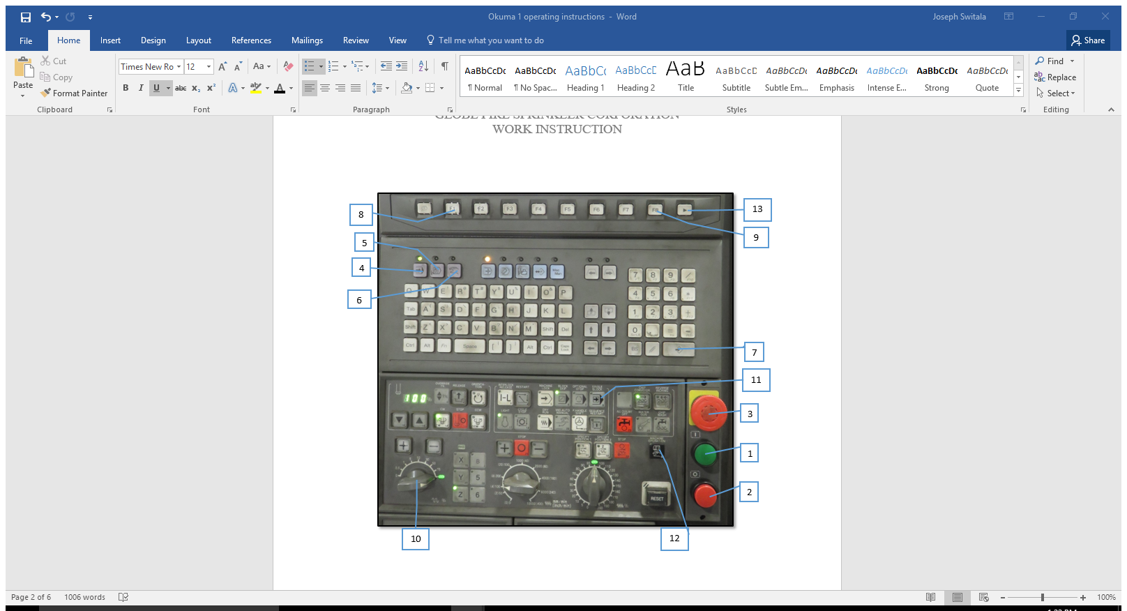

**Figure 1: Main Control Panel**

**1. Cycle Start 2. Feed Hole 3. Emergency Stop 4. Auto 5. MDI 6. Manual 7. Enter 8. F1**

**9. F8 10. Speed Dial 11. Single Block 12. Manual Machine Operation 13. Screen Over**

* 1. Machine Startup

7.1.1 Refer to document No. ## for instructions on machine startup.

7.2. Selecting the program

7.2.1 Press “MDI” then “F1” (Program Select). A list of all the programs will show. Use the arrow keys to scroll through and highlight the desired one. Press “Enter” to select it.

7.2.1.1 The title of the program is the last three digits of the part number. This can be found on the container that the parts are received in.

7.2.1.2 For example, if the part number is 317461, the program name is 0.000461

7.2.3 If changing the program and/or changing products, a complete tool check must be completed.

7.2.3.1 Refer to document No. ## for instructions on performing tool checks.

* 1. Securing valve in the fixture for first operation

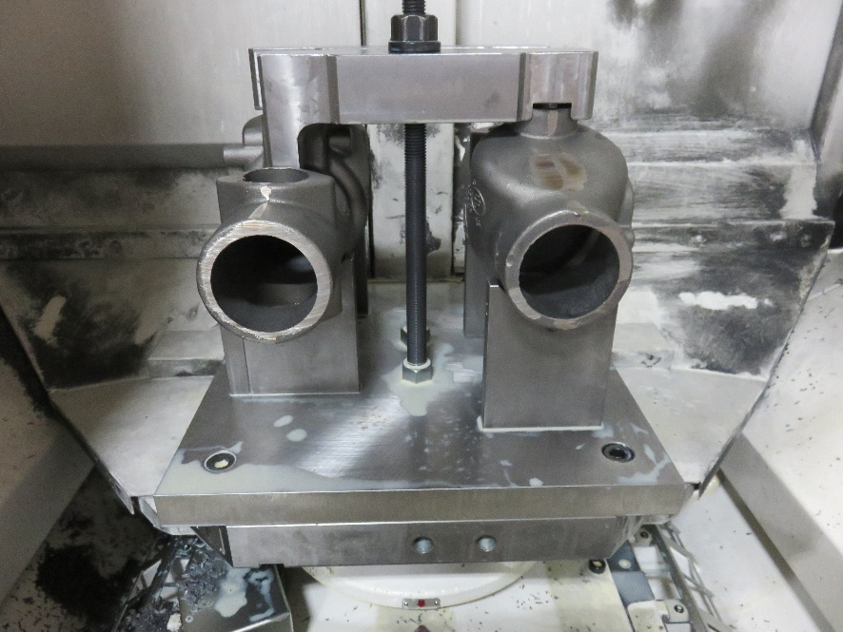

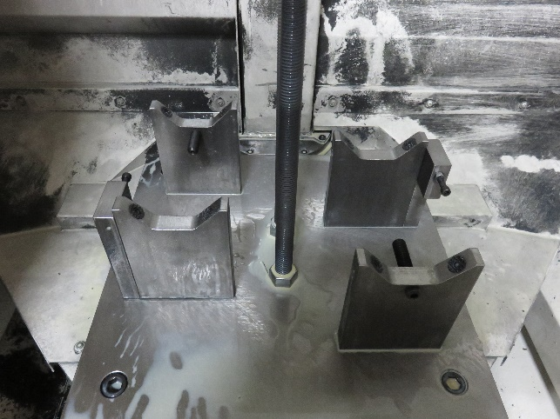

14

16

13

15

15

14

**Figure 2: Empty First Op Fixture Figure 3: First Op Fixture with Valve**

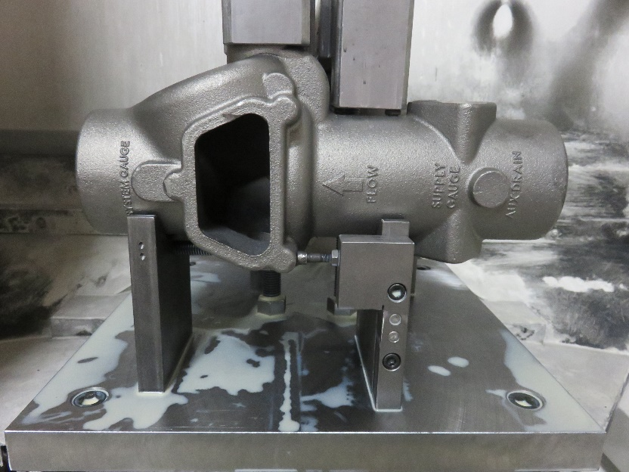

16

**Figure 3: Side View of First Op Fixture**

**14. Top Bars 15. Set Screw 16. Fixed Placement Screw**

7.3.1 Use the air hose to blow off any debris and/or coolant from the fixture.

7.3.2 Unscrew the Top Bars and set them to the side.

7.3.3 Loosen the Set Screw so that it won’t obstruct the valve when it is being placed in the fixture.

7.3.4 Place a valve in the right side of the fixture with the hand-hole facing to the right and the outlet facing the operator. Ensure that the screw boss on the hand holes bottom right side is firmly pressed against the Fixed Screw.

7.3.5 Place a second valve in the left side of the fixture with the hand hole facing to the left and the inlet facing the operator. Again, ensure that the screw boss on the hand hole is firmly pressed against the Fixed Screw.

7.3.6 Level the valves in the fixture by putting a square on the table and pressing it against the hand hole to twist the valve so that the face is straight upright.

7.3.7 While still holding the square against the valve, tighten the Set Screw with the 5/16 allen wrench enough to apply some pressure, however do not fully tighten.

7.3.7.1 Pull the black handle under the loading door to allow the table to be turned so the other Set Screw can be set. Push the handle back in to lock the table.

7.3.8 Place the Top Bars onto the valves through the rods, as shown in Figure 3. Verify the grooves go over one of the right drain bosses and the extension goes on top of the other valve. Both bars will be sitting opposite of each other.

7.3.9 Ensure the valves are still level with the square and tighten the nuts holding the Top Bar.

7.3.10 Fully tighten the showing Set Screw. Rotate the table so it is back in its original position and fully tighten the other Set Screw.

7.3.11 Ensure the table is clear of all tools, close the loading door, and press “Load Finished”. If the button is not pressed then the machine won’t switch between the two operations.

7.4. Starting the machining cycle

7.4.1 Push the button labeled “Auto”. Once selected, press “Cycle Start.”

7.4.2 When using a familiar program make frequent checks and actively listen to the machine for any unusual noises that could suggest disturbance in the process.

7.4.3 If using a new or newly adjusted program stand at the viewing door to monitor the process. If a single tool is added or adjusted monitor that individual tool.

7.4.3.1 To adequately monitor the machining process, adjust the “Speed Dial” to decrease the speed of the machine to 10%. This only has to be done when machining is about to and is taking place, the machine can be set to normal speed while switching tools or moving the table.

7.4.3.2 Before milling, drilling, or tapping occurs, turn off the coolant by pressing “Coolant” and stop the machine by pressing “Feed Hole”. Do **NOT** push “Emergency Stop”. Verify that the tool is in the correct place, then turn the coolant back on and press “Cycle Start” to start the machine again.

7.4.3.3 When monitoring an individual tool, pause the process multiple times to ensure that the tool is adjusted correctly and that the tool/holder won’t damage the product or the fixture.

7.4.4 If running on a normal process skip this step. If running the product for the first time, stop the program by pressing “Single Block” as soon as first op is done and tables start to switch.

7.5 Removing valve from first op fixture

7.5.1 Open the loading door.

7.5.2 Using an air hose, dry off the valves, fixture, and the threads located above the Top Bars.

7.5.3 Unscrew and remove both Top Bars and loosen both Set Screws that are securing the valves in place.

7.5.4 Remove valves from fixture by tapping the hand hole inward with palm to release it. If valve remains wedged in supports, use the 1 1/4" wrench to tap it to release it.

7.5.4.1 Hold the valve inside of the loading area, after it is out of the fixture, dry and clean the entire valve with an air hose, including each hole and bore. This minimizes loss of coolant and prevents debris from dirtying the workplace.

7.5.5 Completely dry fixture with the air hose.

7.5.6 If running on a normal process skip to step 7.5.7. If running the product for the first time, load two castings into the first op fixture and restart the program so there will always be machined valves ready for second op.

7.5.6.1 Before resetting the program the first op fixture must be inside the machine. To do this, press “MDI” then use the keyboard to type “M60”. Press “Enter” then “Cycle Start” and the tables will switch.

7.5.6.2 To restart the program press the black button labeled “Reset”. Press “Auto” then “Cycle Start”. The machine will start on a normal cycle.

7.5.7 Remove any burrs on the inner and outer edges of the hand hole and flow switch boss with a hand grinder.

7.5.8 File the face of the hand hole and flow switch boss, the top of the inlet and outlet, and the bottom edge of the groove on the inlet and outlet.

7.6 Securing valve for second operation

19

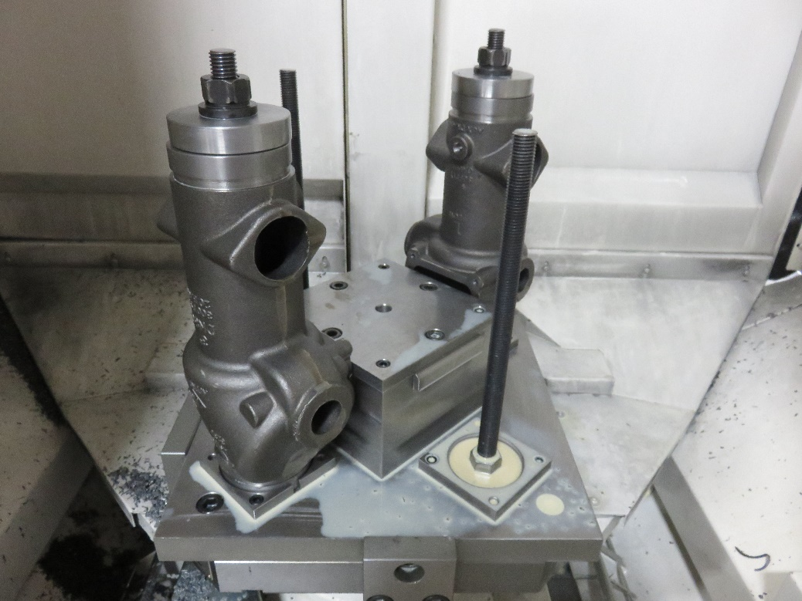

20

17

18

**Figure 4: Second Op Fixture with Valve**

**17. Lock Screws 18. Groove Plate 19. Clamps 20. Spring-Loaded Bar**

7.6.1 Place a valve on the subplate for second op. Verify the outlet hole is aligned with the groove on the subplate.

7.6.2 Place the Clamp on top of the valve’s inlet hole and hand tighten the nut until it just barely touches the Clamp.

7.6.3 Use the 3/8” allen wrench to loosen the Lock on the Spring-Loaded Bar so it evens the valve in the fixture. Slightly tighten the Lock so there is some pressure to keep the wall from sliding back in.

7.6.4 Use the 1 1/4" wrench to tighten the Clamp until there is enough pressure to hold the valve but still allow some rotational movement. Tighten the Lock Screw. Fully tighten the Clamp.

7.6.5 Turn the table and repeat steps 7.6.1-7.6.4 for a new valve on the opposite side.

7.6.6 Turn the table to its original position, close the door, and press “Load Finished”.

7.7 Removing valve from fixture after second operation

7.7.1 Open the loading door. Blow off the accessible valve and fixture with an air hose.

7.7.2 Remove the Clamp.

7.7.3 Lift the valve and remove from fixture. Hold the valve inside of the loading area, after it is out of the fixture, dry and clean the entire valve with an air hose, including each hole and bore. This minimizes loss of coolant and prevents debris from dirtying the workplace.

7.7.4 Place the valve on the bench. Clean shavings and debris out of the Groove Plate with hand and wipe them off the table. Dry and clean the fixture, including the threaded bar, with an air hose.

7.7.5 Place a partially machined valve that completed first op into the second op fixture.

7.7.6 Turn the table and repeat steps 7.7.1- 7.7.5 on the other valve.

7.7.7 Use grinder on the outer edges of both of the drain bosses and both of the flow switch bosses. File the faces of all four bosses as well.

7.7.7.1 While machining and grinding, check the entire machined valve for porosities or defects. If any are found set the valve aside and contact supervisor.

7.7.8 Take the fully machined valves to the measuring table and complete the quality check forms.

7.7.8.1 If the valve is within tolerance then place it in the box on the pallet with the rest of the machined valves. If it doesn’t pass then stop machining and contact supervisor and/or engineer.